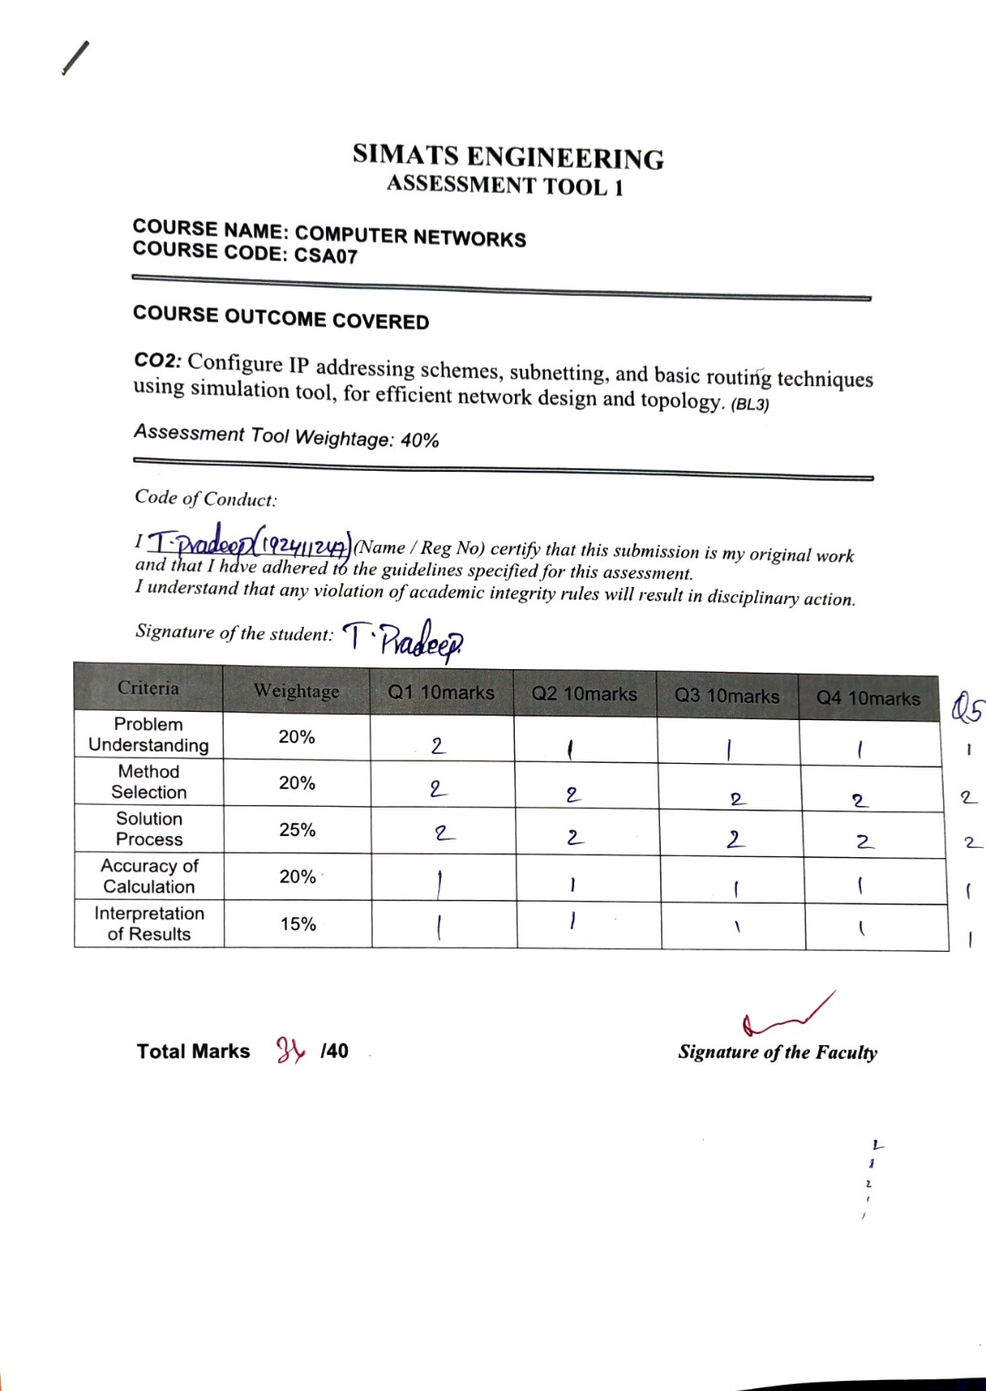

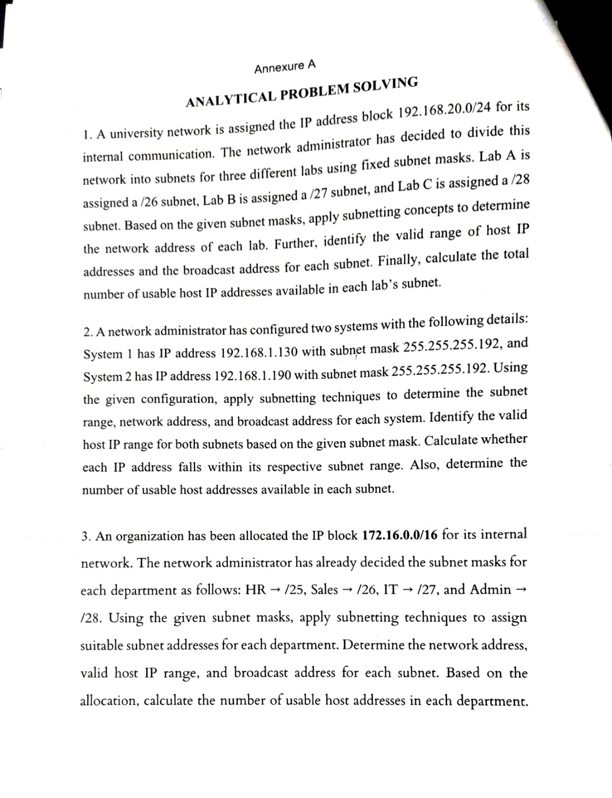

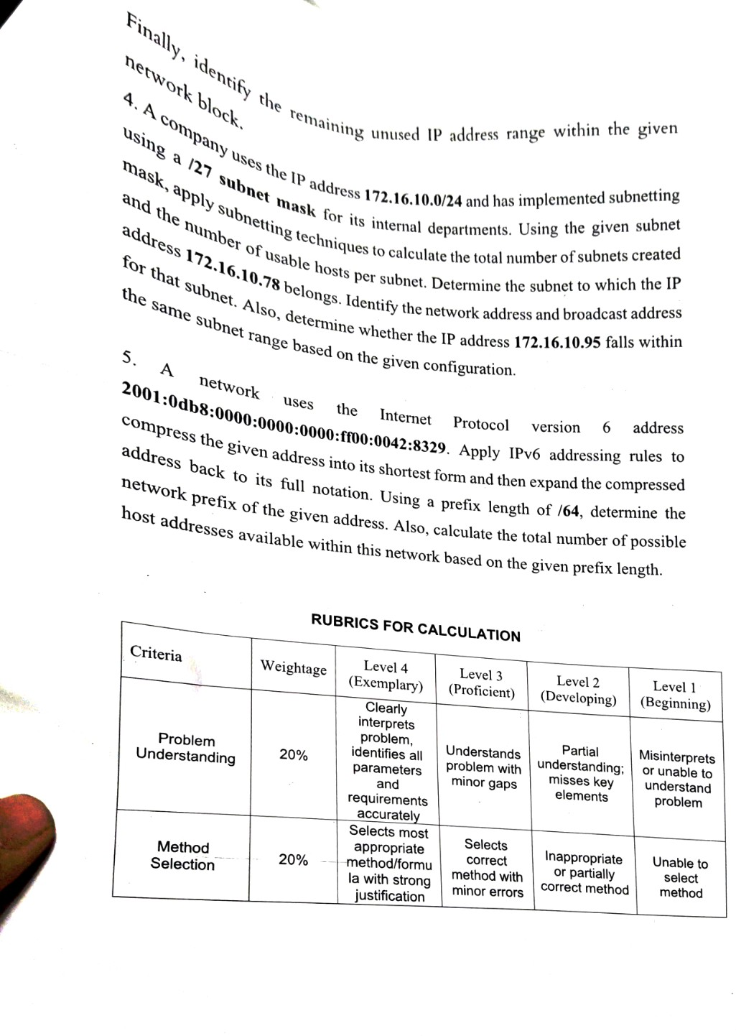

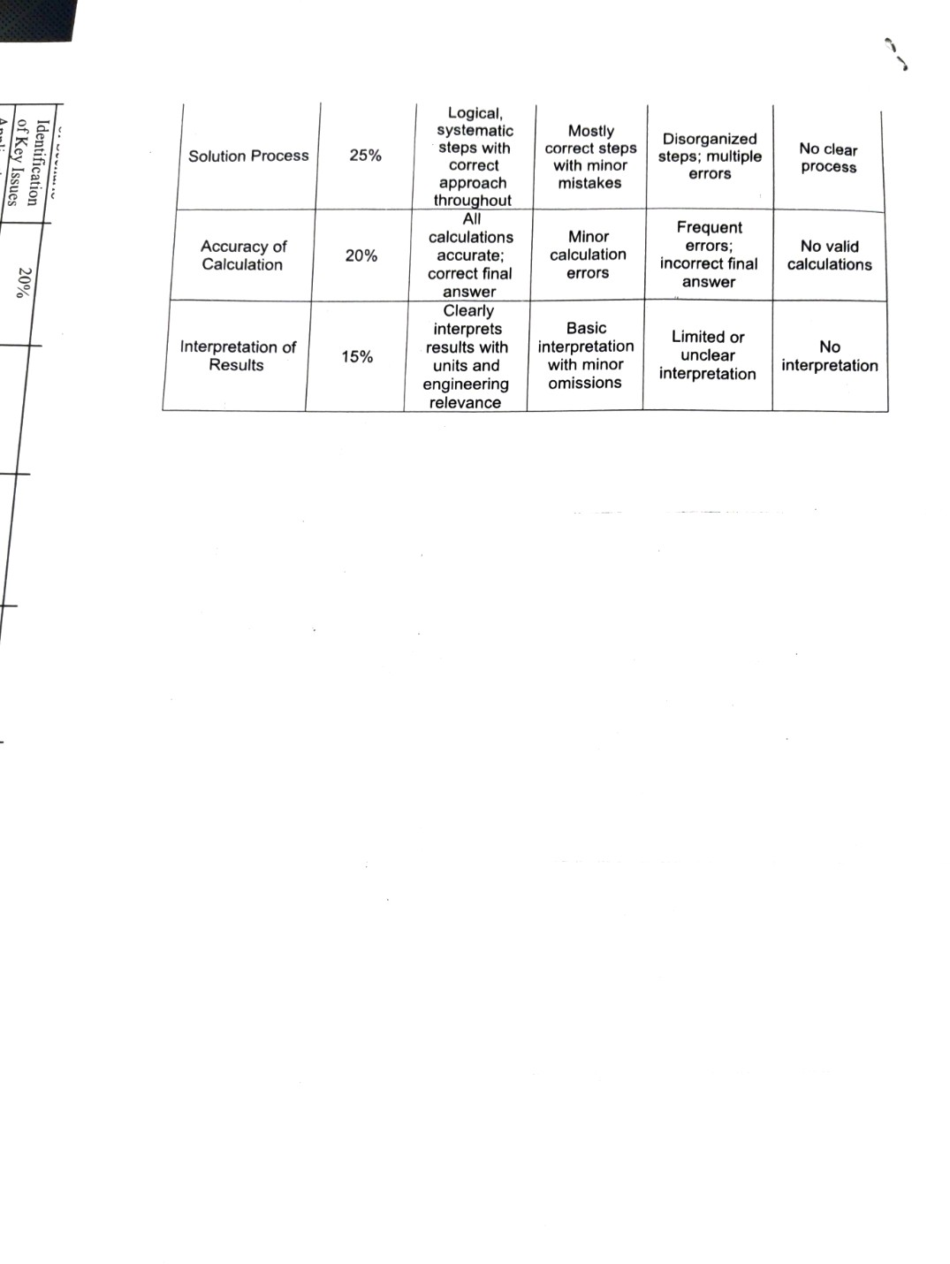

SIMATS ENGINEERING
ASSESSMENT TOOL 1

COURSE NAME: COMPUTER NETWORKS
COURSE CODE: CSA07

COURSE OUTCOME COVERED

CO2: Configure IP addressing schemes, subnetting, and basic routing techniques using simulation tool, for efficient network design and topology. (BL3)

Assessment Tool Weightage: 40%

Code of Conduct:

I ___T. Pradeeep(192411247)___(Name / Reg No) certify that this submission is my original work and that I have adhered to the guidelines specified for this assessment.
I understand that any violation of academic integrity rules will result in disciplinary action.

Signature of the student:T.Pradeep

Criteria | Weightage | Q1 10marks | Q2 10marks | Q3 10marks | Q4 10marks
Problem Understanding | 20%
Method Selection | 20%
Solution Process | 25%
Accuracy of Calculation | 20%
Interpretation of Results | 15%

Total Marks /40 Signature of the Faculty

Annexure A

ANALYTICAL PROBLEM SOLVING

1. A university network is assigned the IP address block 192.168.20.0/24 for its internal communication. The network administrator has decided to divide this network into subnets for three different labs using fixed subnet masks. Lab A is assigned a /26 subnet, Lab B is assigned a /27 subnet, and Lab C is assigned a /28 subnet. Based on the given subnet masks, apply subnetting concepts to determine the network address of each lab. Further, identify the valid range of host IP addresses and the broadcast address for each subnet. Finally, calculate the total number of usable host IP addresses available in each lab’s subnet.
Answer 1
Given
IP block = 192.168.20.0/24 (256 addresses). Lab A = /26, Lab B = /27, Lab C = /28.
Formulae used
Block size = 2^(32 − prefix length).
Usable hosts = 2^(host bits) − 2 (one address is the network address and one is the broadcast address).
Network address = first address of the block; broadcast address = last address of the block; valid hosts = network + 1 to broadcast − 1.
Solution (step by step)
Step 1: Understand the problem
The /24 block has 32 − 24 = 8 host bits, i.e. 2^8 = 256 addresses. Three subnets of different sizes (/26, /27, /28) must be carved out of it one after another without overlapping.
Step 2: Convert each prefix to a subnet mask
/26 = 11111111.11111111.11111111.11000000 = 255.255.255.192 → host bits = 32 − 26 = 6.
/27 = 11111111.11111111.11111111.11100000 = 255.255.255.224 → host bits = 32 − 27 = 5.
/28 = 11111111.11111111.11111111.11110000 = 255.255.255.240 → host bits = 32 − 28 = 4.
Step 3: Find the block size and usable hosts
Lab A: block size = 2^6 = 64; usable hosts = 64 − 2 = 62.
Lab B: block size = 2^5 = 32; usable hosts = 32 − 2 = 30.
Lab C: block size = 2^4 = 16; usable hosts = 16 − 2 = 14.
Step 4: Allocate Lab A (starts at 192.168.20.0)
Network address = 192.168.20.0.
Broadcast address = 0 + 64 − 1 = 63 → 192.168.20.63.
First host = 192.168.20.1; last host = 192.168.20.62.
Step 5: Allocate Lab B (starts where Lab A ends + 1)
Next free address = 63 + 1 = 64, which is a multiple of 32, so the block is correctly aligned.
Network address = 192.168.20.64.
Broadcast address = 64 + 32 − 1 = 95 → 192.168.20.95.
First host = 192.168.20.65; last host = 192.168.20.94.
Step 6: Allocate Lab C (starts where Lab B ends + 1)
Next free address = 95 + 1 = 96, which is a multiple of 16, so the block is correctly aligned.
Network address = 192.168.20.96.
Broadcast address = 96 + 16 − 1 = 111 → 192.168.20.111.
First host = 192.168.20.97; last host = 192.168.20.110.
Final result
Lab | Mask | Network address | Valid host range | Broadcast | Usable hosts
A (/26) | 255.255.255.192 | 192.168.20.0 | 192.168.20.1 – 192.168.20.62 | 192.168.20.63 | 62
B (/27) | 255.255.255.224 | 192.168.20.64 | 192.168.20.65 – 192.168.20.94 | 192.168.20.95 | 30
C (/28) | 255.255.255.240 | 192.168.20.96 | 192.168.20.97 – 192.168.20.110 | 192.168.20.111 | 14

Interpretation
The three labs use 64 + 32 + 16 = 112 addresses (192.168.20.0 – 192.168.20.111) and the subnets do not overlap. The range 192.168.20.112 – 192.168.20.255 (144 addresses) remains free for future expansion. Lab A can connect 62 devices, Lab B 30 devices and Lab C 14 devices.

2. A network administrator has configured two systems with the following details: System 1 has IP address 192.168.1.130 with subnet mask 255.255.255.192, and System 2 has IP address 192.168.1.190 with subnet mask 255.255.255.192. Using the given configuration, apply subnetting techniques to determine the subnet range, network address, and broadcast address for each system. Identify the valid host IP range for both subnets based on the given subnet mask. Calculate whether each IP address falls within its respective subnet range. Also, determine the number of usable host addresses available in each subnet.
Answer 2
Given
System 1: 192.168.1.130, System 2: 192.168.1.190, both with subnet mask 255.255.255.192 (/26).
Formulae used
Network address = IP address AND subnet mask.
Broadcast address = network address with all host bits set to 1.
Usable hosts = 2^(host bits) − 2.
Solution (step by step)
Step 1: Understand the mask
255.255.255.192 = 11111111.11111111.11111111.11000000 → prefix /26. The first 2 bits of the last octet are network bits and the last 6 bits are host bits.
Block size = 256 − 192 = 64, so the subnets in the last octet start at 0, 64, 128 and 192.
Step 2: Convert the last octet of each IP address to binary
System 1: 130 = 10000010.
System 2: 190 = 10111110.
Mask: 192 = 11000000.
Step 3: Find the network address (IP AND mask)
System 1: 10000010 AND 11000000 = 10000000 = 128 → network 192.168.1.128.
System 2: 10111110 AND 11000000 = 10000000 = 128 → network 192.168.1.128.
Both systems give the same network address, so they are in the same subnet.
Step 4: Find the broadcast address (host bits all 1)
Network 10000000 with host bits set to 1 → 10111111 = 191.
Broadcast address = 192.168.1.191 (also 128 + 64 − 1 = 191).
Step 5: Find the valid host range
First host = network + 1 = 192.168.1.129 (10000001).
Last host = broadcast − 1 = 192.168.1.190 (10111110).
Step 6: Check whether each IP lies in its subnet
System 1: 129 ≤ 130 ≤ 190 → valid host, inside the subnet.
System 2: 129 ≤ 190 ≤ 190 → valid host (the last usable address), inside the subnet.
Step 7: Calculate usable hosts
Host bits = 6 → 2^6 = 64 addresses − 2 = 62 usable hosts in each subnet.
Final result
Item | System 1 (192.168.1.130) | System 2 (192.168.1.190)
Subnet range | 192.168.1.128 – 192.168.1.191 | 192.168.1.128 – 192.168.1.191
Network address | 192.168.1.128 | 192.168.1.128
Broadcast address | 192.168.1.191 | 192.168.1.191
Valid host range | 192.168.1.129 – 192.168.1.190 | 192.168.1.129 – 192.168.1.190
IP within its subnet? | Yes | Yes
Usable hosts | 62 | 62

Interpretation
Both systems belong to the same subnet 192.168.1.128/26, so they can communicate directly without a router. System 2 uses the last valid host address (.190); it is still valid because the broadcast address is .191.

3. An organization has been allocated the IP block 172.16.0.0/16 for its internal network. The network administrator has already decided the subnet masks for each department as follows: HR → /25, Sales → /26, IT → /27, and Admin → /28. Using the given subnet masks, apply subnetting techniques to assign suitable subnet addresses for each department. Determine the network address, valid host IP range, and broadcast address for each subnet. Based on the allocation, calculate the number of usable host addresses in each department. Finally, identify the remaining unused IP address range within the given network block.
Answer 3
Given
IP block 172.16.0.0/16 (65,536 addresses). HR = /25, Sales = /26, IT = /27, Admin = /28.
Formulae used
Block size = 2^(32 − prefix). Usable hosts = block size − 2. Broadcast = network address + block size − 1.
Solution (step by step)
Step 1: Find the mask, block size and usable hosts of each department
HR /25: 255.255.255.128, host bits 7, block size 128, usable hosts 126.
Sales /26: 255.255.255.192, host bits 6, block size 64, usable hosts 62.
IT /27: 255.255.255.224, host bits 5, block size 32, usable hosts 30.
Admin /28: 255.255.255.240, host bits 4, block size 16, usable hosts 14.
Step 2: Decide the allocation order
Allocate from the largest to the smallest subnet (HR → Sales → IT → Admin) starting at 172.16.0.0, so that every block starts on a correct boundary and no addresses are wasted.
Step 3: Allocate HR (/25)
Network = 172.16.0.0; broadcast = 0 + 128 − 1 = 127 → 172.16.0.127.
Valid hosts = 172.16.0.1 – 172.16.0.126.
Step 4: Allocate Sales (/26)
Starts at 127 + 1 = 128 (multiple of 64). Network = 172.16.0.128; broadcast = 128 + 64 − 1 = 191 → 172.16.0.191.
Valid hosts = 172.16.0.129 – 172.16.0.190.
Step 5: Allocate IT (/27)
Starts at 191 + 1 = 192 (multiple of 32). Network = 172.16.0.192; broadcast = 192 + 32 − 1 = 223 → 172.16.0.223.
Valid hosts = 172.16.0.193 – 172.16.0.222.
Step 6: Allocate Admin (/28)
Starts at 223 + 1 = 224 (multiple of 16). Network = 172.16.0.224; broadcast = 224 + 16 − 1 = 239 → 172.16.0.239.
Valid hosts = 172.16.0.225 – 172.16.0.238.
Step 7: Find the unused address range
Addresses used = 128 + 64 + 32 + 16 = 240 (172.16.0.0 – 172.16.0.239).
Next free address = 172.16.0.240.
Unused range = 172.16.0.240 – 172.16.255.255, which is 65,536 − 240 = 65,296 addresses.
Final result
Dept | Mask | Network address | Valid host range | Broadcast | Usable hosts
HR (/25) | 255.255.255.128 | 172.16.0.0 | 172.16.0.1 – 172.16.0.126 | 172.16.0.127 | 126
Sales (/26) | 255.255.255.192 | 172.16.0.128 | 172.16.0.129 – 172.16.0.190 | 172.16.0.191 | 62
IT (/27) | 255.255.255.224 | 172.16.0.192 | 172.16.0.193 – 172.16.0.222 | 172.16.0.223 | 30
Admin (/28) | 255.255.255.240 | 172.16.0.224 | 172.16.0.225 – 172.16.0.238 | 172.16.0.239 | 14

Unused range: 172.16.0.240 – 172.16.255.255 (65,296 addresses).
Interpretation
All four departments fit inside the first 240 addresses of the block with no overlap. Their capacities are 126, 62, 30 and 14 hosts. The large unused range can be used to create more subnets in the future.

4. A company uses the IP address 172.16.10.0/24 and has implemented subnetting using a /27 subnet mask for its internal departments. Using the given subnet mask, apply subnetting techniques to calculate the total number of subnets created and the number of usable hosts per subnet. Determine the subnet to which the IP address 172.16.10.78 belongs. Identify the network address and broadcast address for that subnet. Also, determine whether the IP address 172.16.10.95 falls within the same subnet range based on the given configuration.
Answer 4
Given
Network 172.16.10.0/24 subnetted with /27 (255.255.255.224). Addresses to test: 172.16.10.78 and 172.16.10.95.
Formulae used
Number of subnets = 2^(subnet bits). Usable hosts = 2^(host bits) − 2. Block size = 256 − (last mask octet).
Solution (step by step)
Step 1: Find the subnet bits and host bits
Original prefix = /24, new prefix = /27, so subnet bits borrowed = 27 − 24 = 3.
Host bits = 32 − 27 = 5.
Mask: 255.255.255.224 = 11111111.11111111.11111111.11100000.
Step 2: Calculate the number of subnets and hosts
Number of subnets = 2^3 = 8.
Usable hosts per subnet = 2^5 − 2 = 32 − 2 = 30.
Step 3: List all the subnets (block size = 256 − 224 = 32)
The subnets start at 0, 32, 64, 96, 128, 160, 192 and 224 (see the table below).
Subnet no. | Network address | Valid host range | Broadcast
1 | 172.16.10.0 | 172.16.10.1 – 172.16.10.30 | 172.16.10.31
2 | 172.16.10.32 | 172.16.10.33 – 172.16.10.62 | 172.16.10.63
3 | 172.16.10.64 | 172.16.10.65 – 172.16.10.94 | 172.16.10.95
4 | 172.16.10.96 | 172.16.10.97 – 172.16.10.126 | 172.16.10.127
5 | 172.16.10.128 | 172.16.10.129 – 172.16.10.158 | 172.16.10.159
6 | 172.16.10.160 | 172.16.10.161 – 172.16.10.190 | 172.16.10.191
7 | 172.16.10.192 | 172.16.10.193 – 172.16.10.222 | 172.16.10.223
8 | 172.16.10.224 | 172.16.10.225 – 172.16.10.254 | 172.16.10.255

Step 4: Find the subnet of 172.16.10.78 (binary method)
78 = 01001110 and mask 224 = 11100000.
78 AND 224 = 01000000 = 64 → network address = 172.16.10.64.
Broadcast = host bits all 1 → 01011111 = 95 → 172.16.10.95.
Valid hosts = 172.16.10.65 – 172.16.10.94. So 172.16.10.78 belongs to the 3rd subnet, 172.16.10.64/27.
Step 5: Check 172.16.10.95
95 = 01011111; 95 AND 224 = 01000000 = 64 → the same network, 172.16.10.64.
All 5 host bits of 95 are 1, so 172.16.10.95 is the broadcast address of this subnet.
It lies within the subnet range (64 – 95) but it is not a valid host address.
Final result
Item | Value
Total subnets | 8
Usable hosts per subnet | 30
Subnet of 172.16.10.78 | 172.16.10.64/27
Network address | 172.16.10.64
Broadcast address | 172.16.10.95
Is 172.16.10.95 in the same subnet? | Yes – it is the broadcast address of 172.16.10.64/27 (not assignable to a host)

Interpretation
172.16.10.78 is a valid host in subnet 172.16.10.64/27. The address 172.16.10.95 falls in the same subnet range, but since it is the broadcast address it cannot be given to any device; the last usable host address is 172.16.10.94.

5. A network uses the Internet Protocol version 6 address 2001:0db8:0000:0000:0000:ff00:0042:8329. Apply IPv6 addressing rules to compress the given address into its shortest form and then expand the compressed address back to its full notation. Using a prefix length of /64, determine the network prefix of the given address. Also, calculate the total number of possible host addresses available within this network based on the given prefix length.
Answer 5
Given
IPv6 address 2001:0db8:0000:0000:0000:ff00:0042:8329 with prefix length /64.
Rules used
Compression: (1) remove leading zeros in every 16-bit group; (2) replace the longest run of consecutive all-zero groups with "::" (allowed only once in an address).
Expansion: restore the zero groups hidden by "::" until there are 8 groups, then pad each group to 4 hexadecimal digits.
An IPv6 address has 128 bits = 8 groups of 16 bits. The network prefix is the first /64 bits (first 4 groups); the remaining 64 bits are the interface (host) ID.
Solution (step by step)
Step 1: Split the address into its 8 groups
2001 | 0db8 | 0000 | 0000 | 0000 | ff00 | 0042 | 8329
Step 2: Remove leading zeros from each group
0db8 → db8, 0000 → 0, 0042 → 42.
Result: 2001:db8:0:0:0:ff00:42:8329.
Step 3: Replace the consecutive all-zero groups with "::"
Groups 3, 4 and 5 are all zero (0:0:0) and form the longest zero run.
Compressed (shortest) form: 2001:db8::ff00:42:8329.
Step 4: Expand the compressed address back to full form
2001:db8::ff00:42:8329 has 5 written groups (2001, db8, ff00, 42, 8329).
The "::" must therefore represent 8 − 5 = 3 zero groups: 2001:db8:0:0:0:ff00:42:8329.
Pad every group to 4 digits: 2001:0db8:0000:0000:0000:ff00:0042:8329, which is the original address.
Step 5: Find the network prefix for /64
64 bits = 4 groups, so keep the first four groups: 2001:0db8:0000:0000.
Network prefix = 2001:db8::/64 (the interface ID is 0000:ff00:0042:8329).
Step 6: Calculate the number of host addresses
Host (interface ID) bits = 128 − 64 = 64.
Total addresses = 2^64 = 18,446,744,073,709,551,616 (about 1.8 × 10^19).
Final result
Item | Result
Compressed form | 2001:db8::ff00:42:8329
Expanded form | 2001:0db8:0000:0000:0000:ff00:0042:8329
Network prefix (/64) | 2001:db8::/64
Interface ID | ::ff00:42:8329
Number of host addresses | 2^64 = 18,446,744,073,709,551,616

Interpretation
IPv6 does not use a broadcast address, so the "− 2" used in IPv4 is not applied; all 2^64 interface IDs are available in the /64 (the all-zeros ID is reserved as the subnet-router anycast address). A /64 is the standard subnet size for a LAN.

RUBRICS FOR CALCULATION

Criteria | Weightage | Level 4 (Exemplary) | Level 3 (Proficient) | Level 2 (Developing) | Level 1 (Beginning)
Problem Understanding | 20% | Clearly interprets problem, identifies all parameters and requirements accurately | Understands problem with minor gaps | Partial understanding; misses key elements | Misinterprets or unable to understand problem
Method Selection | 20% | Selects most appropriate method/formula with strong justification | Selects correct method with minor errors | Inappropriate or partially correct method | Unable to select method
Solution Process | 25% | Logical, systematic steps with correct approach throughout | Mostly correct steps with minor mistakes | Disorganized steps; multiple errors | No clear process
Accuracy of Calculation | 20% | All calculations accurate; correct final answer | Minor calculation errors | Frequent errors; incorrect final answer | No valid calculations
Interpretation of Results | 15% | Clearly interprets results with units and engineering relevance | Basic interpretation with minor omissions | Limited or unclear interpretation | No interpretation

